BASIC PROBABILITY

1.0 INTRODUCTION
Probability concepts are familiar to everyone. The weather forecaster states that the probability of rain tomorrow is twenty percent. At the racetrack, the odds are three to one that a certain horse will win the fifth race. Relating probability concepts to manufacturing operations may not be as familiar as the above examples, but they work the same way. Probability is the key to assessing the risks involved in the decision-making process. The gambling casinos determine the probabilities for each game of chance then make the rules so that the odds are always in their favor. The same can be done for manufactured products. The probability of a certain number of defective parts in a large lot can be determined. Also, the percentage of parts within a certain dimension range can be predicted. If the desired results are not obtained, then adjustments to the process can be made. Adjustments to a process in a manufacturing operation are analogous to changing the rules in a casino game. The objective is to obtain the desired results.
Since a major portion of statistical quality control and statistical process control deals with probability concepts, it is important to have a good knowledge of probability. In a manufacturing operation, there are very few occasions when complete information is available. Therefore, information must be generalized from samples and limited known facts. It is sometimes surprising to discover the vast amount of information and knowledge about a process that can be obtained from a relatively small amount of data. Probability is the building block of statistics and statistical quality control.

2.0 EVENTS
An event is defined as any outcome that can occur. There are two main categories of events: Deterministic and Probabilistic.
A deterministic event always has the same outcome and is predictable 100% of the time.
- Distance traveled = time x velocity
- The speed of light
- The sun rising in the east
- James Bond winning the fight without a scratch
A probabilistic event is an event for which the exact outcome is not predictable 100% of the time.
- The number of heads in ten tosses of a coin
- The winner of the World Series
- The number of games played in a World Series
- The number of defects in a batch of product
In a boxing match there may be three possible events. (There could be more depending on the question asked.)
- Fighter A wins
- Fighter B wins
- Draw
2.1 Four Basic Types of Events
- Mutually Exclusive Events: These are events that cannot occur at the same time. The cause of mutually exclusive events could be a force of nature or a man made law. Being twenty-five years old and also becoming president of the United States are mutually exclusive events because by law these two events cannot occur at the same time.
- Complementary Events: These are events that have two possible outcomes. The probability of event A plus the probability of A' equals one. P(A) + P(A') = 1. Any event A and its complementary event A' are mutually exclusive. Heads or tails in one toss of a coin are complementary events.
- Independent Events: These are two or more events for which the outcome of one does not affect the other. They are events that are not dependent on what occurred previously. Each toss of a fair coin is an independent event.
- Conditional Events: These are events that are dependent on what occurred previously. If five cards are drawn from a deck of fifty-two cards, the likelihood of the fifth card being an ace is dependent on the outcome of the first four cards.

3.0 PROBABILITY
Probability is defined as the chance that an event will happen or the likelihood that an event will happen.
The definition of probability is
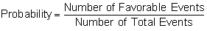
The favorable events are the events of interest. They are the events that the question is addressing. The total events are all possible events that can occur relevant to the question asked. In this definition, favorable has nothing to do with something being defective or non-defective.
What is the probability of a head occurring in one toss of a coin?
The number of favorable events is 1 (one head) and the number of total events is 2 (head or tail). In this case, the probability formula verifies what is obvious.
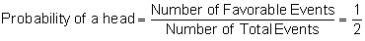
Probability numbers always range from 0 to 1 in decimals or from 0 to 100 in percentages.
3.1 Notation for Probability Questions
Instead of writing out the whole question, the following notation is used.
- What is the probability of event A occurring? = Probability (A) = P(A)
- What is the probability of events A and B occurring? = P(A and B) = P(A) and P(B)
- What is the probability of events A or B occurring? = P(A or B) = P(A) or P(B)
3.2 Probability in Terms of Areas
Probability may also be defined in terms of areas rather than the number of events.
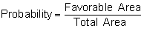
Example 1
A plane drops a parachutist at random on a seven by five mile field. The field contains a two by one mile target as shown below. What is the probability that the parachutist will land in the target area? Assume that the parachutist drops randomly and does not steer the parachute.

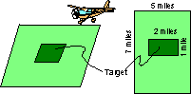
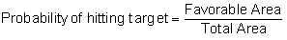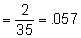

4.0 METHODS TO DETERMINE PROBABILITY VALUES
There are three major methods used to determine probability values.
- Subjective Probability: This is a probability value based on the best available knowledge or maybe an educated guess. Examples are betting on horse races, selecting stocks or making product-marketing decisions.
- Priori Probability: This is a probability value that can be determined prior to any experimentation or trial. For example, the probability of obtaining a tail in tossing a coin once is fifty percent. The coin is not actually tossed to determine this probability. It is simply observed that there are two faces to the coin, one of which is tails and that heads and tails are equally likely.
- Empirical Probability: This is a probability value that is determined by experimentation. An example of this is a manufacturing process where after checking one hundred parts, five are found defective. If the sample of one hundred parts was representative of the total population, then the probability of finding a defective part is .05 (5/100). The question may be asked: How is it known that this sample is representative of the total population? If repeated trials average .05 defective, with little variation between trials, then it can be said that the empirical probability of a defective part is .05.

5.0 MULTIPLICATION THEOREM
The multiplication theorem is used to answer the following questions:
- What is the probability of two or more events occurring either simultaneously or in succession?
- For two events A and B: What is the probability of event A and event B occurring?
The individual probability values are simply multiplied to arrive at the answer. The word "and" is the key word that indicates multiplication of the individual probabilities. The multiplication theorem is applicable only if the events are independent. It is not valid when dealing with conditional events. The product of two or more probability values yields the intersection or common area of the probabilities. The intersection is illustrated by the Venn diagrams in section 11.0 of this chapter. Mutually exclusive events do not have an intersection or common area. The probability of two or more mutually exclusive events is always zero.
For mutually exclusive events:
- P(A) and P(B) = 0
For independent events:
- Probability (A and B) = P(A) and P(B) = P(A) X P(B)
For multiple independent events, the multiplication formula is extended. The probability that five events A, B, C, D and E occur is
P(A) and P(B) and P(C) and P(D) and P(E) = P(A) x P(B) x P(C) x P(D) x P(E)

Example 2
What is the probability of getting a raise and that the sun will shine tomorrow?
Given: Probability of getting a raise = P(r) = .10
Probability of the sun shining = P(s) = .30
The events are independent.
P(raise) and P(sunshine) = P(r) x P(s) = .10 x .30 = .03 or 3%

6.0 ADDITION THEOREM
The addition theorem is used to answer the following questions:
- What is the probability of one event or another event or both events occurring?
- What is the probability of event A or event B occurring?
The word "or" indicates addition of the individual probabilities. The answers to the above questions are different depending on whether the events are mutually exclusive or independent.
Mutually exclusive events do not have an intersection or common area. The individual probabilities are simply added to arrive at the answer. For mutually exclusive events:
- P(A or B) = P(A) or P(B) = P(A) + P(B)
- P(A or B or C or D) = P(A) + P(B) + P(C) + P(D)
For two independent events, the intersecting or common area must be subtracted or it will be included twice. (Refer to the Venn diagram in section 11.0).
Probability (A or B) = P(A) or P(B) = P(A) + P(B) – P(A X B)
For three independent events:
P(A or B or C) = P(A) + P(B) + P(C) – P(A X B) – P(A X C) – P(B X C) + P(A X B X C)

Example 3
What is the probability of getting a raise or that the sun will shine tomorrow?
Given: Probability of getting a raise = P(r) = .10
Probability of the sun shining = P(s) = .30
P(raise) or P(sunshine) = P(r) or P(s) = P(r or s)
P(r or s) = P(r) + P(s) - [P(r) x P(s)] = .10 + .30 - [.10 X .30] = .40 - .03 = .37 or 37%
The word "and" is associated with the multiplication theorem and the word "or" is associated with the addition theorem.

7.0 COUNTING TECHNIQUES - PERMUTATIONS AND COMBINATIONS
Permutations and combinations are simply mathematical tools used for counting. In many cases, it may be cumbersome to count the number of favorable events or the number of total events when solving probability problems. Permutations and combinations help simplify the task.
7.1 Permutations
A permutation is an arrangement of things, objects or events where the order is important. Telephone numbers are special permutations of the numerals 0 to 9 where each numeral may be used more than once. The order defines each unique telephone number.
In the following example, it is assumed that each object is unique and cannot be used more than once. The letters A, B, and C may be arranged in the following ways:
ABC BAC CAB
ACB BCA CBA
This is an ordered arrangement, because ABC is different than BCA. Since the order of the letters makes a difference, each arrangement is a permutation. From the above example, It is concluded that there are six permutations that can be made from three objects. The general formula for permutations is
_{n} P_{r} = 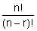
n = The total objects to arrange
r = The number of objects taken from the total to be used in the arrangements
By definition: 0! = 1 and 1! = 1

Example 4
Using the permutation formula and the three letters A, B and C, how many permutations can be made using all three letters?
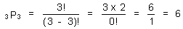
Example 5
How many permutations can be made by using two out of the three letters?
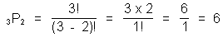
The permutations are
AB BA BC
AC CA CB
Example 6
There are three different assembly operations to be performed in making a certain part. There are nine people working on the floor. How many different assembly crews can be formed?

This may be stated as the number of permutations that can be made from nine objects used three at a time.
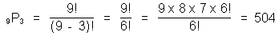
7.2 Combinations
A combination is a grouping or arrangement of objects where the order does not make a difference.
The arrangement of the letters ABC is the same as BCA. The number of combinations that can be made by using three letters, three at a time, is one. This can be expanded to state that the number of combinations that can be made by using n letters, n at a time, is one. A hand of five cards consisting of a Jack, a Queen, a King, and two Aces is the same as a Queen, two Aces, a Jack and a King. The order in which the cards were received makes no difference. There is only one combination that can be made by using five cards, five at a time.
The formula for combinations is
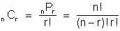
n = Total objects to arrange
r = Number of objects taken from the total to be used in the arrangements
The symbol for number of combinations is often shown as
When the symbol appears in a formula, the number of combinations is to be computed using the combination formula.
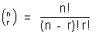
Example 7
From the three letters A, B and C, how many combinations can be made by using two out of the three letters?
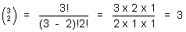

The combinations are
AB AC BC
BA is the same as AB
CA is the same as AC
CB is the same as BC
Example 8
Ten parts have been manufactured. Two parts are to be inspected for a critical dimension. How many different sample arrangements can be made?
If the parts are labeled 1 to 10, then parts 1 and 5 make one arrangement, parts 3 and 7 make another, 6 and 8 another, etc. The listing of the various arrangements can be completed and total arrangements counted. The combination formula can perform this task and save a considerable amount of time.
The total arrangements or combinations that can be made:
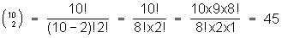
The permutation and combination formulas are very useful tools in evaluating and solving probability problems. It is often necessary to count the number of favorable and total events that can occur. Without these counting techniques, this would be a very cumbersome and sometimes impossible task.

8.0 PROBABILITY DISTRIBUTIONS
Probability distributions and their associated formulas and tables allow us to solve a wide variety of problems in a logical manner. Probability distributions are classified as discrete or continuous. Three discrete distributions will be reviewed in this chapter. Continuous distributions are covered in the next chapter. Probability distributions are used to generate sampling plans, predict yields, arrive at process capabilities, determine the odds in games of chance and many other applications.
The three discrete distributions that will be reviewed:
- The Hypergeometric Probability Distribution
- The Binomial Probability Distribution
- The Poisson Probability Distribution
One of the most difficult tasks for a beginning student in probability is to know which distribution or formula to use for a specific problem. A roadmap is given in section 10.0 of this chapter to assist in the task.
The quality engineer may be asked to calculate the probability of the number of defects or the number of defective units in a sample. There is a difference between the two phrases. A defect is an individual failure to meet a requirement. A defective unit is a unit of product that contains one or more defects. Many defects can occur on one defective unit.
8.1 The Hypergeometric Probability Distribution
The hypergeometric distribution is the basic distribution of probability. The hypergeometric probability formula is simply the number of favorable events divided by the number of total events. It can be described as the true basic probability distribution of attributes. To use the hypergeometric formula, the following values must be known.
N = The total number of items in the population (lot size)
n = The number of items to be selected from the population (sample size)
A = The number in the population having a given characteristic
B = The number in the population having another characteristic
a = The number of A that is desired to occur
b = The number of B that is desired to occur

The hypergeometric probability formula is
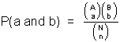

Example 9
An urn contains fifteen balls, five red and ten green. What is the probability of obtaining exactly two red and three green balls in drawing five balls without replacement?
This question may also be stated as:
- What is the probability of obtaining two red balls?
- What is the probability of obtaining three green balls?
All three questions are the same. When setting up the problem, all events must be considered regardless of how the question is asked.
In this case, the probability of a single event is not constant from trial to trial. This is the same as sampling without replacement. The outcome of the second draw will be affected by what was obtained on the first draw. The number of favorable events and the number of total events must be computed.
The number of ways that red balls may be selected:
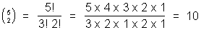
The number of ways that green balls may be selected:
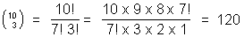
The total number of ways to select a sample of five balls from a population of fifteen balls:
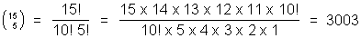
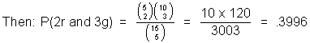
This is a specific application of the hypergeometric probability formula. Many similar problems may be solved using this method. To use the hypergeometric formula, the population must be small enough so that the number of items with the characteristics in question can be determined.
Example 10
A box contains ten assemblies of which two are defective. A sample of three assemblies is selected at random. What is the probability that the two defective parts will be selected? (For this to occur there must be two defective parts and one good part in the sample.)
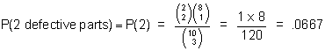
8.2 The Binomial Probability Distribution
The binomial probability formula is used when events are classified in two ways such as good/defective, red/green, go/no-go, etc. The prefix Bi means two. The events or trials must be independent. When the binomial formula is used, it is assumed that the lot size is infinite and the probability of a single success is constant from trial to trial.
The binomial probability formula is be used to answer the following question: What is the probability of x successes in n trials where the probability of a single success is p? .
The binomial formula is
Example 11
A coin is tossed five times. (This is the same as a sample size of five). What is the probability of obtaining exactly two heads in the five tosses?
It is known, by prior knowledge, that the probability of a single success (probability of a head in one toss of a coin) is fifty percent. The question is looking for two successes or two heads in five tosses of a coin. A success is the outcome that is desired to occur.

For this example:
- The number of trials = n = 5
- The probability of a single event = p = 1/2
- The number of successes that the question is seeking (x = 2).
To arrive at the answer to the question the values are entered in the binomial formula.
Example 12
In manufacturing screwdrivers, it was empirically determined that the process yields, on average, 5% defective product. What is the probability that in a sample of ten screwdrivers there are exactly three defective units?
n = 10, p = .05, x = 3

Example 13
A company produces electronic chips by a process that normally averages 2% defective products. A sample of four chips is selected at random and the parts are tested for certain characteristics.
- What is the probability that exactly one chip is defective?
- What is the probability that more than one chip is defective?
More than one defective chip in a sample of four means two, three or four defective chips. The probability of each may be calculated using the binomial formula.
P(more than 1 defective chip) = P(2) or P(3) or P(4) = P(2) + P(3) + P(4)
In any trial or sample, the sum of the probabilities of the individual events always equal one. In this problem: P(0) + P(1) + P(2) + P(3) + P(4) = 1
P(more than 1 defective) = 1 - [P(0) + P(1)] = 1 - [.9224 +.0753] = .0023

8.3 The Poisson Probability Distribution
The Poisson distribution is the mathematical limit to the binomial distribution and may be used to approximate binomial probabilities. The Poisson is also a distribution in its own right when solving problems involving defects per unit rather than fraction defectives. Tables showing subsets of Poisson probabilities appear in many textbooks. The tables greatly simplify the solution of many problems. The most extensive Poisson table is Poisson's Exponential Binomial Limit by E. C. Molina. The tables were developed in the 1920s and published in 1949.
If n is large and p is small so that n times p (np) is a positive number less than five, then the Poisson is a good approximation to the binomial. The value p and the ratio n/N should be less than 0.10.
When solving binomial problems with the Poisson formula, the terms n, x and p are the same as in the binomial formula. The task is to calculate the probability of x successes in n trials, where the probability of a single success is p. Remember that p is a fraction defective when used to approximate the binomial, and p is defects per unit when counting the number of defects instead of the number of defective units.
In some cases neither n nor p is given, but the product np may be given. If p is a fraction defective then np is the average number of defective units in the sample. If p is in terms of defects per unit then np is the average number of defects in the sample.

The Poisson formula is
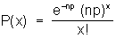

Example 14
In making switches, it has been determined by empirical studies that there is, on average, one defect per switch. What is the probability of selecting a sample of five switches that contains zero defects? There are two methods to solve this problem. The first method is to use the above formula where x = 0, n = 5, and p = 1, therefore
np = 5 x 1 = 5.
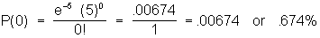
The second and most widely used method is to use the Poisson tables that are published in most statistics books. To use the tables, find the value of x in the leftmost column, then find the value of np on the top row and read P(x) at the intersection of the two values.
The Poisson table value for P(0) = .006738 or .674%
Example 15
In a paper making operation it was found that each 1000 foot roll contained, on average, one defect. One roll is selected at random from the process.
- What is the probability that this roll contains zero defects?
Use the Poisson table where x = 0 and np = 1. The Poisson table value for P(0) = .368.
- What is the probability that the roll contains exactly three defects?
The Poisson table value for P(3) = .061
- What is the probability that this roll contains more than one defect?
P(more than one defect) = P(2) + P(3) + P(4) + … + P(∞ )
= 1 - [P(0) + P(1)]
= 1 - [.368 + .368] = .264
Example 16
In manufacturing the Que model car, a study determined that on average there are three defects per car. What is the probability of buying a Que with less than three defects?
P(less than 3 defects) = P(0) + P(1) + P(2)
Use the Poisson tables and find P(0), P(1) and P(2) where np = 3
P(less than 3 defects) = .049 + .149 + .224 = .422

9.0 CONDITIONAL PROBABILITY
Conditional probability is defined as the probability of an event occurring if another has occurred or has been specified to occur simultaneously, and the outcome of the first event affects the probability of the second event. Conditional events are not independent.
The probability of B occurring given that A has already occurred is stated as P(B/A), where the symbol / means "given that."
The formulas for conditional probability are shown below. These are known as Bayes Formulas.
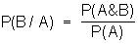
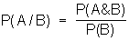
Since the two formulas have a common term P(A & B), they may be used together to solve many problems involving conditional probability.
Conditional events are not independent so P(A & B) is not equal to P(A) X P(B). From Bayes formulas:

P(A & B) = P(B/A) P(A)
P(A & B) = P(A/B) P(B)

Example 17
A lot of fifteen items contains five defective items. Two items are drawn at random. What is the probability that the second item drawn will be defective?
Let A = event that first item is defective
Let A' = event that first item is good
Let B = event that second item is defective
The question stated in probability terms: what is P(B) = ?
P(A) = 5/15, P(A') = 10/15
P(B) = P(A & B) or P(A' & B) → P(first item defective & second item defective) or
P(first item good & second item defective)
P(B) = P(B/A) P(A) or P(B/A') P(A')
P(B) = P(B/A) P(A) + P(B/A') P(A')
P(B) = (4/14)(5/15) + (5/14)(10/15)
P(B) = (20/210) + (50/210) = 70/210 = .333

Example 18
It has been found that 10% of certain relays have bent covers and will not work. If 40% have bent covers, what is the probability that a relay with a bent cover will not work?
Let A = event that relays have bent covers
Let B = event that relays will not work
Given: P(A & B) = .10, P(A) = .40
The first formula of the conditional probability formulas, Bayes formulas, gives the following solution:
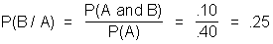

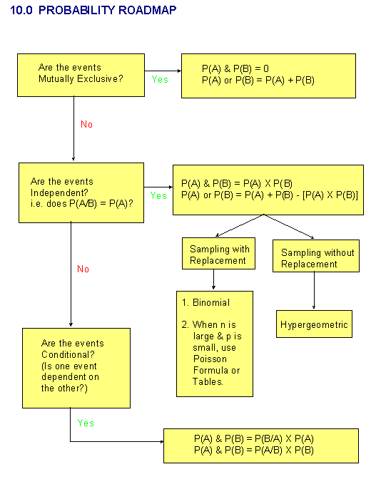
•

11.0 VENN DIAGRAMS
Venn diagrams show the events and corresponding probabilities in graphical form. The events are shown as circles and the shaded area within the circles represent the probabilities.
